[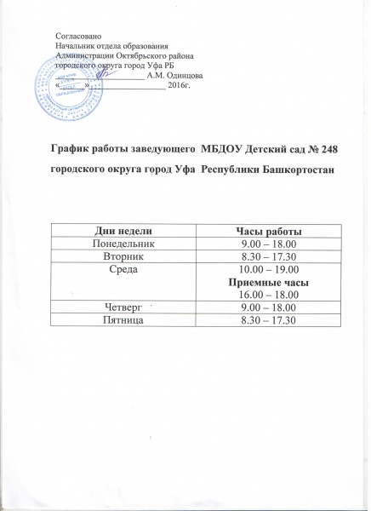](http://248.детсад-уфа.рф/%d0%be%d1%81%d0%bd%d0%be%d0%b2%d0%bd%d1%8b%d0%b5-%d1%81%d0%b2%d0%b5%d0%b4%d0%b5%d0%bd%d0%b8%d1%8f/%d0%b3%d1%80%d0%b0%d1%84%d0%b8%d0%ba-%d1%80%d0%b0%d0%b1%d0%be%d1%82%d1%8b-%d0%b7%d0%b0%d0%b2%d0%b5%d0%b4%d1%83%d1%8e%d1%89%d0%b5%d0%b9/)